1. If you want to view report, then you need to click on the **CLICK HERE** button (View Traders Report) on the middle left of our Dashboard. After clicking it, it will redirect you to Oracle Dashboard from where you can login with your username and password.

1. Clicking on the button will get you to the login page of Oracle Apex. You need to sign in with your login credentials.

1. ADMIN_DASHBOARD displays Sales Over Time, User Per Role, Highest Selling Shop, Top Selling Products through various charts.

1. You can view Weekly Sales Report of each shop.

1. You can view Monthly Sales Report of each shop.

1. You have access to view your Product Reviews on the master detail page and also delete the reviews.

1. You have access to view your shop and their products report on the master detail page.

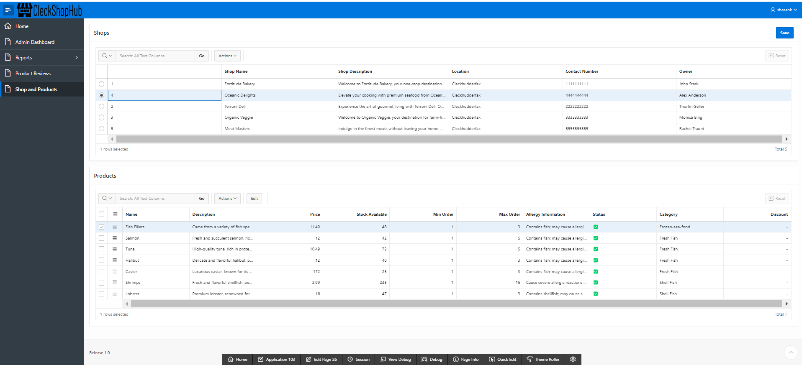s

1. Click the button with your username/email at the top right, click on sign out option to logout.

